

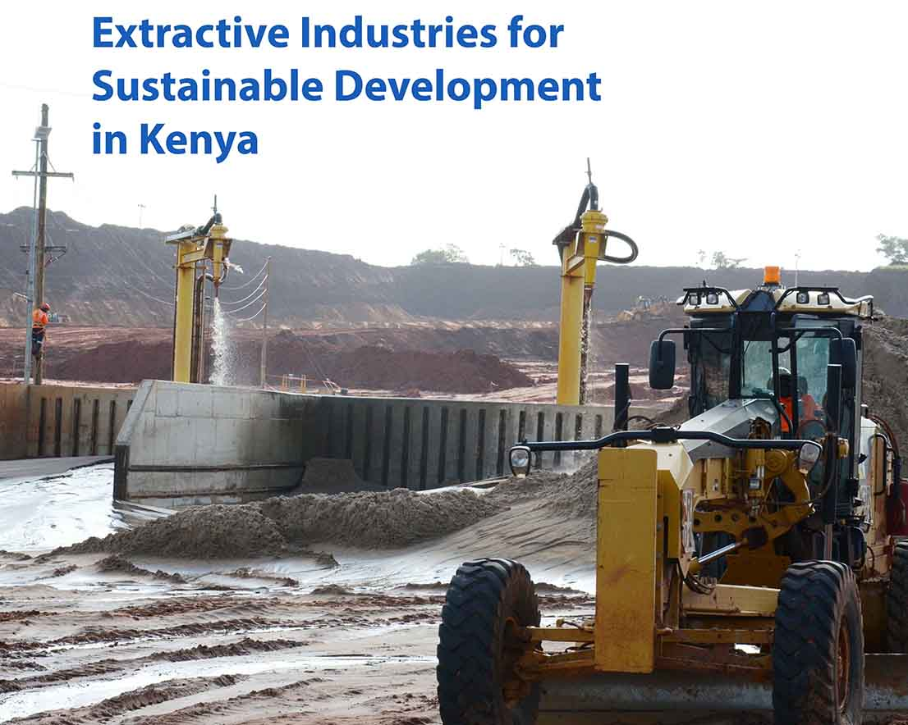

**Progress Report**

**January 2014-August 2014**

Table of Contents

Introduction 4

Country Context 4

Collaboration with the Government of Kenya 5

Project Summary 6

Progress towards Project Activities Supported by DFID 9

**Activity 1 Output 1:** Support the Development of Capacities of Communities for conflict resolution and accountability mechanisms 9

**Activity 2 Output 1**: Develop information dissemination mechanisms of communication in counties 10

**Activity 3 Output 1:** Support capacity development for regulation of artisanal and small scale mining at national and local level 13

**Activity 4 Output 1**: Support the establishment of dispute resolution mechanisms 14

**Activity 7 Output 2:** Utilizing UNDP best practice knowledge networks, conduct review of experiences with community investment funds 16

**Activity 8 Output 2**: Building on Corporate Social Investment Initiatives 16

**Activity 9 Output 2:** Carry out supply chain analysis 18

**Activity 11 Output 3:** Conduct a study on existing legislation 19

**Activity 13 Output 3**: Undertake socio-economic studies and assessments to inform evidence based policy formulation and implementation in the extractive sector. 20

**Activity 14 Output 3**: Carry out conflict risk analyses to identify drivers of conflict, peace capacities, traditional and non-traditional dispute resolution mechanisms 21

Project Management systems established for effective project implementation. 22

Resource Utilization 23

Lessons Learned 23

Way Forward Error! Bookmark not defined.

Annual Work plan 2014 25

**Acronyms**

AfDB – African Development Bank

CIDP - County Integrated Development Plan

CPD - Country Programme Document

DDU – Democratic Governance Unit

DFID - UK Department for International Development

EECCU - Energy, Environment and Climate Change Unit

GoK – Government of Kenya

ICES - Information Centre for the Extractive Sector in Kenya

IEG – Inclusive Economic Growth

KCM – Kenya Chamber of Mines

KOGA – Upstream Oil and Gas Association of Kenya

MoDP - Ministry of Devolution and Planning

MoM – Ministry of Mining

MTPII – Medium Term Plan II

PBCP - Peace Building and Conflict Prevention

UNDAF- United Nations Development Assistance Framework

UNDP – United Nations Development Programme

# Introduction

In 2013, under the auspices of the UNDP Global Programme for Extractive Industries and UNDP Regional Africa Programme for Extractive Industries, the UNDP Kenya developed the “Extractive Industries for Sustainable Human Development” project. The project aims to improve the lives of people living in areas endowed with natural resources by improving governance, economic empowerment, promoting peace and environmental sustainability.

The two-year project (2014-2015) was signed by the National Treasury in November 2013 and implementation began in January 2014. The projects estimated budget is USD 2.8 Million for the two years. The first year of activities is fully funded with USD 1.35 Million USD provided by the UK Department for International Development (DFID) and the UNDP. UNDP funding was made available in the last quarter of 2013 and DFID funding became available at the end of February, 2014. The work plan and activities for 2014 began being implemented in January 2014.

This report provides the status of activities beginning January 1, 2014 through the period of August 30, 2014. It reports only on the activities that were planned for this period and assesses whether progress has been realized. This report is meant to inform various stakeholders including Donors (both internal and external), the Government of Kenya and other relevant partners in the project implementation.

# Country Context

The Government of Kenya (GoK), recognizing the importance of the new discoveries and the economic potential of these natural resources, has prioritized Oil and Other Minerals in its Vision 2030 and Medium Term Plan II (MTP II). Under the Economic Pillar in the MTP II, the seventh priority includes Oil and other Minerals and lists over 20 projects that the Government of Kenya will implement during the 2013-2017 timeframe. During the first half of 2014 the Government of Kenya has focused its work on updating relevant legislation and policy. Specifically, the Draft Mining Bill, the Draft Energy Bill and Draft National Energy Policy have been developed during the first six months of the year.

The United Nations (UN) System in Kenya has aligned its programming with Government of Kenya priorities through the new United Nations Development Framework (UNDAF) 2014-2018. Under Strategic Result Area 3 for Inclusive and Sustainable Economic Growth, UN Agencies have agreed to support the extractive sector. The expected output is an extractive sector that is technically strengthened to apply measures that protect the environment, generate employment opportunities particularly for women, youth and marginalized groups, and invest in community development and social services. Emanating from the UNDAF, the UNDP Country Programme Document (CPD) for 2014-2018 has similarly prioritized activities to ensure sustainable human development for communities endowed with natural resources.

The extractive sector is complex and includes a number of different stakeholders. Development partners meet monthly through a Donor Technical Working Group to ensure activities are coordinated and aligned. Private sector is also working to harmonize Corporate Social Responsibility efforts through the Upstream Kenya Oil and Gas Association (KOGA) and Kenya Chamber of Mines (KCM). A number of think tanks, academic institutions, civil society organisations and media are also involved in activities aimed at improving human development in the extractive sector. For this reason the African Development Bank (AfDB) launched the Information Centre for the Extractive Sector in Kenya (ICES) in December 2013.

The UNDP Kenya began in January 2014 within this complex, yet potential-filled environment. By achieving the project outcomes, the project hopes to improve livelihoods in affected communities.

# Collaboration with the Government of Kenya

The project was signed by the National Treasury in November 2013, as per the guidelines set out by the Government of Kenya regarding development assistance. However, in March 2014 the National Treasury issued a letter to the Ministry of Mining requesting that the Ministry of Mining become the primary implementing partner for the project. According to UNDP rules and procedures, the implementing partner is entrusted with the implementation of all agreed upon project activities defined in the project document in consultation with UNDP.

While the Ministry of Mining is the primary implementing partner, several other government bodies are involved in the implementation of the project. These include the Ministry of Energy and Petroleum, the Ministry of Devolution and Planning, the Ministry of Industrialization, the National Environmental Management Authority, the Ministry of Interior and the Office of the Attorney General. During the first year of project implementation, the planned activities were to be effected in four counties selected according to human development criteria, geographical and natural resource diversity. The project was designed to work closely with the County Governments of Turkana, Kitui, Kwale and Taita Taveta. The Ministry of Mining shall assist in coordinating all the government stakeholders for implementation of the project. This was to be done through a National Steering Committee and a Technical Steering Committee. A Project Coordinator is also being hired within the Ministry of Mining to coordinate the activities planned for implementation. At the start of Quarter 3 it is expected that the implementation modalities for the National Steering Committee, Technical Steering Committee and the 2014 Work Plan will be validated and put in place. Also, the Project Coordinator will be hired.

# Project Summary

The project has three main output components and activities as indicated below. However the DfID contribution was earmarked for specific activities as highlighted and whose implementation progress is illustrated in the next section. The three project areas with outputs and activities are outlined below:

1. **Participatory decision-making fora established to institutionalize participation and inclusion of communities in decisions on extractive industries, to safeguard rights and promote collaborative engagement between communities, government and private sector.**

Activities under this output include:

1. **Capacities in Extractive Industries Developed**:

This would be achieved through the implementation of the following activities:

1. *support the development of capacities of communities by raising awareness and enhancing their participation in Extractive Industries projects*
2. *develop information dissemination mechanisms through training of media personnel*
3. *support capacity development for regulation of artisanal and small-scale mining*
4. conduct a collaborative leadership training for leaders on conflict-sensitive approaches to extractive industries
5. **Dispute Resolution Mechanisms in Extractive Industry established** through:
   1. *support the establishment of dispute resolution mechanisms to address conflicts between communities and private companies or within communities over extraction activities*
6. **Public institutions, the private sector and civil society have systems to ensure transparent, accountable and inclusive management of revenues from extractive industries.**

Activities under this output include:

1. **Extractive Industry Partnerships developed and maintained** by:
2. organizing Private-Public-Dialogue (PPD)
3. *conducting a review of experiences with community investment funds in other countries*
4. *building on Corporate Social Responsibility (CSR) initiatives of extractive companies and enhancing capacities of SMEs in Extractive Industry*
5. **Supply Chain Analysis:**
   1. *carry out supply chain analysis of SMEs inform their capacity as suppliers to Extractive Industries*
6. **Legal, policy frameworks and institutional capacity is in place to effectively support sustainable management of the extractive sector.**

Activities under this output include:

1. Completion of Extractive Industry assessments and studies:
   1. undertake studies on artisanal and small-scale mining to identify the economic and job creation potentials
   2. *conduct a study on existing legislation, policy and formal and informal mechanisms for community participation and environmental sustainability*
   3. undertake socio-economic studies and assessments to inform evidence based policy formulation and implementation in the extractive sector
   4. *carry out conflict risk analyses to identify drivers of conflict, peace capacities, traditional and non-traditional dispute resolution mechanisms*
2. Institutional capacity developed:
   1. support the capacity of government institutions to carry out monitoring and enforcement of environmental standards, laws and regulations; as well as capacity to develop policy and legal frameworks on the decommissioning of mines

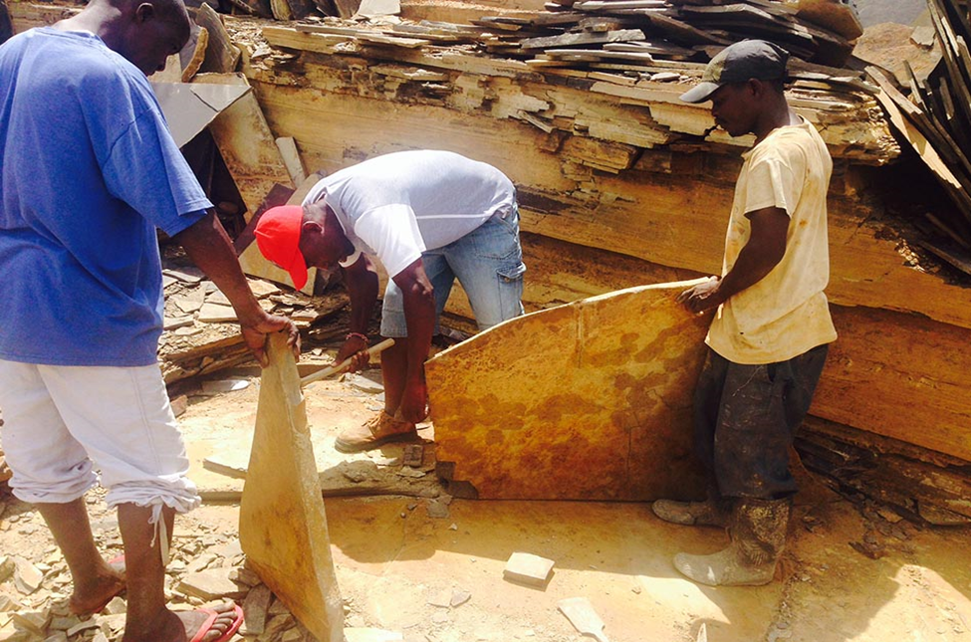

***Poor mining techniques of mazerus in Kwale***

# Progress towards Project Activities Supported by DFID

***Output 1: Participatory decision-making fora established to institutionalize participation and inclusion of communities in decisions on extractive industries, to safeguard rights and promote collaborative engagement between communities, government and private sector.***

## **Activity 1 Output 1:** Support the Development of Capacities of Communities for conflict resolution and accountability mechanisms

Scheduled Timeframe: Quarter 3

Status: On Track

Description of the activity

A national consultation workshop on extractive industries to be held from the 15th to the 19th of September, 2014 in Naivasha.

|  |  |  |  |  |
| --- | --- | --- | --- | --- |
| Activity | UNDP Unit | Partners | Donor | Budgeted Amount |
| Support the development of capacities of communities, including rights organizations, women’s advocacy organizations and minority groups, by raising awareness and enhancing their participation in decision-making, dialogue for conflict resolution and accountability mechanisms | DGU  PBCP | Ministry of Mining, County Governments, Community, Civil Society, Private Sector | DFID | $20,000.00 |

Results:

1. During the workshop the development of the curriculum content on CSOs capacity building training covering collaborative leadership, decision making, conflict prevention and advocacy skills will be reviewed.
2. Develop the schedule for the capacity building trainings in the three selected counties (Kwale, Turkana and Kitui).
3. Initial visits been undertaken in the target Counties of Turkana, Kwale and Kitui.

Challenges:

The delay in implementation was occasioned by the process of negotiating the buy in by all stakeholders.

## **Activity 2 Output 1**: Develop information dissemination mechanisms of communication in counties

Scheduled Timeframe: Quarter 2 and Quarter 3

Status: On Track

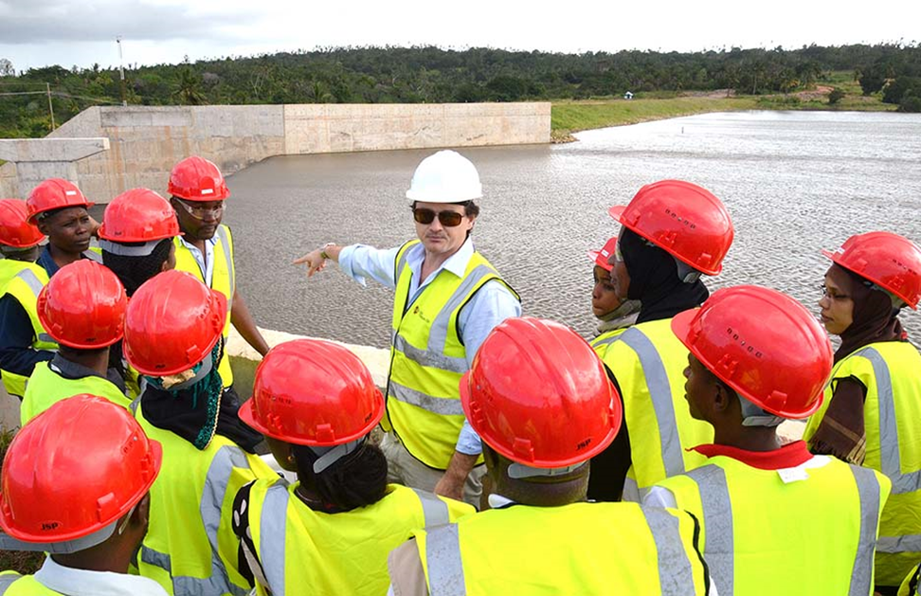

***Base Titanium conducts a site visit with journalists as part of a training session in the extractive industry in Kwale County, Kenya.***

Description of the activity:

This was led by UNDP’s Communication Team and it involved a partnership with the Media Council of Kenya. The activity organized three county level trainings for local journalists on the extractive sector. It also involved the training of editors in Nairobi to ensure those reporting on Extractive Industries understand the extractive process and can accurately report on issues concerning communities and human development. Other partners involved in this training were the Ministry of Mining, Ministry Energy and Petroleum, Kenya Upstream Oil and Gas Association and companies working in the extractives who participated in the panel discussions and allowed tours at their facilities.

|  |  |  |  |  |
| --- | --- | --- | --- | --- |
| Activity | UNDP Unit | Partners | Donor | Budgeted Amount |
| Develop information dissemination mechanisms to population in general, as well as targeting the communities in counties with oil, gas and mineral resources, over the extraction life-cycle, using traditional and non-conventional systems of communication. | COMM | Media Council of Kenya, KOGA, Ministry of Mining, Ministry of Energy and Petroleum | DFID | $40,000.00 |

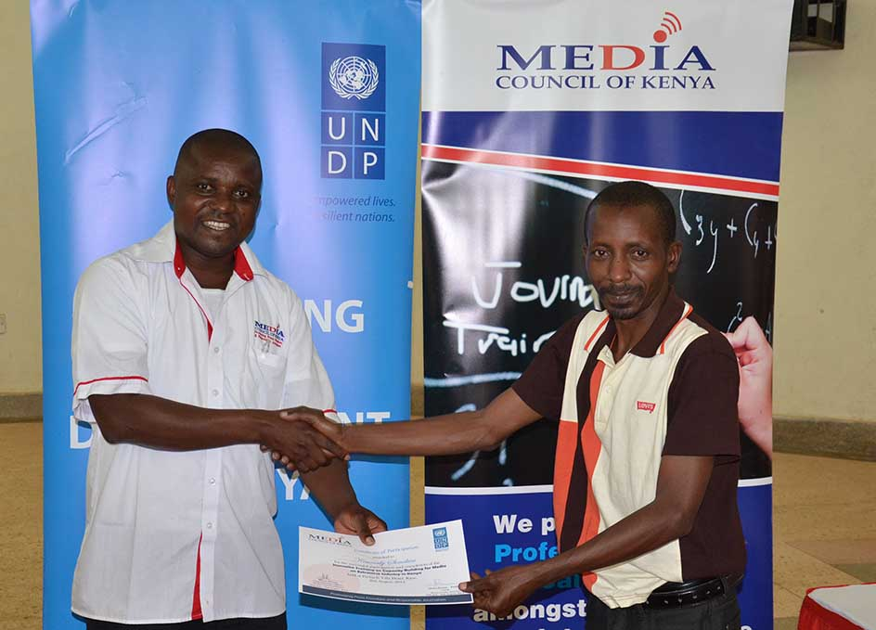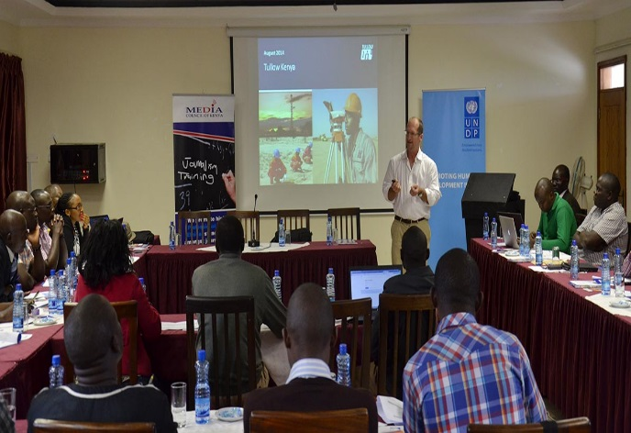

***Victor Bwire – MCK awards a certificates, Kitui Robert Gerrits - Tullow Oil presents at the editors training***

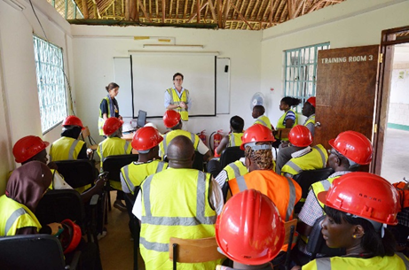 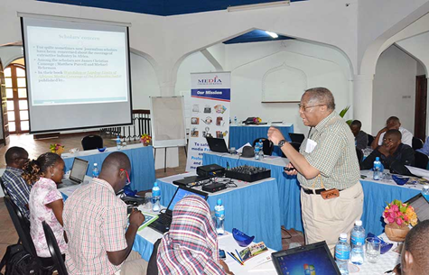

***Journalists trained on safety in Kwale Joe Kadhi – USIU making a presentation on Media Ethics***

Results:

* Four trainings of journalists and editors concluded in Kwale, Kitui, Lodwar and Naivasha.
* A total of 120 journalists and editors have been trained with an average of 25 per region representing all media houses and sections (print, radio and TV) attending.
* Communication officers from the selected counties also took part in the training with representation and participation from relevant ministries from the county governments.
* Instant impact resulting from the trainings as the journalist generated stories on the extractive industry in different local media platforms. Below are links to select stories; Daily Nation [Link](http://www.nation.co.ke/counties/Mining-Data-Workshop-Kwale-Kenya-Government-Experts/-/1107872/2382784/-/kdrgy7/-/index.html) [Link](http://www.nation.co.ke/oped/Letters/Illegal-laws-in-counties-might-frustrate-investment-in-mining-/-/440806/2428194/-/15e95v1/-/index.html) The Standard [Link](http://www.standardmedia.co.ke/m/?articleID=2000130383&story_title=Contract-now-specifies-key-benefits-for-residents-in-coal-mining-project) The Star [Link](http://allafrica.com/stories/201407140429.html) KNA [Link](http://kenyanewsagency.go.ke/?p=30787)
* Commitment from NTV to produce and screen a high level extractive industry feature and conduct an exclusive interview with the Minister for Energy and Petroleum David Chirchir
* The Business Daily newspaper has offered a weekly opinion piece on the extractive industry in Kenya. Dr. Odote one of our facilitators will initially make regular contributions to this column.
* Industry players committed to making information readily available to both local and national journalists to reduce the existing information gap.
* Trained journalists committed to upholding ethical principles in reporting on extractive industry.

Challenges:

* Scanty and inadequate access to information by journalist on extractives in Kenya
* Poor relations and coordination between the national and county government
* There is need for more funds to carry out dissemination to the general public through media and IEC material.
* Lack of a centralized location / resource center on extractives in Kenya.
* Lack of specialization by journalists in Kenya

Planned Activities for way forward after the media trainings

* Media Monitoring - To be able to evaluate the impact of the trainings, there is need to conduct a short term media monitoring and evaluation of content from media sources on extractives (before and after) the trainings.
* Documentation – For enhanced awareness and outreach, we aim to produce a short documentary on the extractive industry in Kenya and also publish a manual for journalist using the content derived from the trainings. These can be used for reference and as resource materials.
* Information Dissemination – Support the Ministry of Mining to develop a communications strategy to ensure more efficient dissemination of information. Lack of information was a major complaint from journalist during the trainings.

## **Activity 3 Output 1:** Support capacity development for regulation of artisanal and small scale mining at national and local level

Scheduled Timeframe: Quarter 2 and Quarter 3

Status: On Course

Description of the activity:

A study was to be conducted on existing legislation, policy and formal and informal mechanisms for community participation; This study on community would focus on the engagement of Tiomin/ Base Titanium in Kwale to inform nationwide community engagement frameworks and guidelines; The study will also cover on the impact of extractive sector development on women, in particular on land rights and tenure security, gender-based violence, and income-earning opportunities.

|  |  |  |  |  |
| --- | --- | --- | --- | --- |
| Activity | UNDP Unit | Partners | Donor | Budgeted Amount |
| Support capacity development for regulation of artisan and small scale mining at national and local levels | IEG | Ministry of Mining; County Governemet, KCM | DFID | $30,000 |

Results: The consultant is on board to carry out a study on artisanal mining in Taita Taveta County; during this study, IEG shall identify the different groups of small-scale artisanal miners in the county. Other than the study, plans are underway to conduct a training on the safe use of explosive in mines, as well as procure protective gear and equipment for the miners. This is to be done in collaboration with the County Government.

Field Visits scheduled for Taita Taveta on that week beginning September 15, 2014 to meet the different stakeholders and artisanal miners and plan for a workshop to build capacities of the small scale / artisanal miners.

Challenges: None

## **Activity 4 Output 1**: Support the establishment of dispute resolution mechanisms

Scheduled Timeframe: Quarter 2 and Quarter 3

Status: On Course

Description of the activity:

This activity is being led by UNDP’s Peace Building and Conflict Prevention unit. The activity involves supporting development of ADR mechanism for use in conflict resolution in extractive industries interactions especially between companies/investors and host/local communities in the 3 Counties of Kitui, Kwale and Turkana.

|  |  |  |  |  |
| --- | --- | --- | --- | --- |
| Activity | UNDP Unit | Partners | Donor | Budgeted Amount |
| Support the establishment of dispute resolution mechanisms, including ADRs, to address conflicts between communities and companies or within communities over extraction activities. | PBCB, DGU | Interior and Coordination, CSOs, Judiciary, Parliament | DFID | $70,000 |

Results:

1. Initial consultations held with the Judiciary and Commission on Implementation of the Constitution with a view to anchor the this activity in the larger framework of developing and institutionalizing the ADR mechanism in the Kenya justice system in line with the spirit of article 159(2) and (3)
2. Through the Extractives Project, UNDP will support a stakeholders consultative forum on application of ADR in Extractives dispute resolution framework in mid-September 2014
3. Preliminary processes have been completed for commissioning of a Pilot Study on ADR contemporary application and efficacy in in at least two Counties

Challenges:

* There is scanty documented information about ADR mechanism in the Country
* Consultative processes among the institutional stakeholders is slow paced

***Output 2: Public institutions, the private sector and civil society have systems to ensure transparent, accountable and inclusive management of revenues from extractive industries.***

For the reporting period of Quarter 1 and Quarter 2, no activities were planned under this output. However, advance progress has been made on one of the activities.

## **Activity 7 Output 2:** Utilizing UNDP best practice knowledge networks, conduct review of experiences with community investment funds

Scheduled Timeframe: Quarter 2 and Quarter 3

Status:

Description of the activity:

A study is to be conducted on community investment funds to identify lessons learnt and make recommendations.

|  |  |  |  |  |
| --- | --- | --- | --- | --- |
| Activity | UNDP Unit | Partners | Donor | Budgeted Amount |
| Utilizing UNDP best practice knowledge networks, conduct review of experiences with community investment funds in other countries , including both successful and less successful ones in order to identify lessons | SPAU | Ministry of Mining; | DFID | $30,000 |

Results: UNDP is working with the government in planning on how the study will be conducted and the areas to be covered.

## **Activity 8 Output 2**: Building on Corporate Social Investment Initiatives

Scheduled Timeframe: Quarter 3 and Quarter 4

Status: on track

Description of the activity:

This activity would initiate a discussion around building on Corporate Social Responsibility initiatives of extractive companies, facilitate public-private dialogues and training workshops for building supply linkages between with local small- and middle-sized enterprises

|  |  |  |  |  |
| --- | --- | --- | --- | --- |
| Activity | UNDP Unit | Stakeholders | Donor | Budgeted Amount |
| Building on Corporate Social Investment Initiatives of extractive companies, facilitate public-private dialogues and training workshops for building supply linkages with small and middle –sized enterprises and to initiate apprenticeship programmes to develop skills and employment opportunities for local communities, with a focus on women and youth . | IEG, | Ministry of Mining, County Government, Private Sector, Community, civil Society | DFID | $150,000.00 |

Results:

The first of Corporate Social Responsibility workshop and engagements shall be held the week of 8th – 15th September, 2014 in Kwale while other workshops planned for Kitui and Turkana at later dates. During the workshop, a seminar will also be held with community representatives, CSOs and the Kwale County Government to build on their engagement in community development, peacebuilding, Corporate Social Responsibility (CSR) initiatives of EI companies and Private-Public Dialogue (PPD). A consultant has been hired to carry out a detailed profile of the Civil Society Organizations (CSOs) in Kwale County, understand their engagement with the various stakeholders and then carry out the five (5) day training workshop for the CSOs, Kwale Government officials and Communities.

Challenges: None.

## **Activity 9 Output 2:** Carry out supply chain analysis

Scheduled Timeframe: Quarter 3 and Quarter 4

Status: on course

Description of the activity:

This activity is scheduled to carry out supply chain analysis to inform the development of small- and medium-size enterprises as suppliers to the extractive industry, drawing on lessons from countries with more mature extractive sectors.

|  |  |  |  |  |
| --- | --- | --- | --- | --- |
| Activity | UNDP Unit | Stakeholders | Donor | Budgeted Amount |
| Carry out supply chain analysis at National level and in Kwale and Kitui Counties to inform the development of small- and medium-size enterprises as suppliers to the extractive industry, drawing on lessons from countries with more mature extractive sectors. | IEG | Ministry of Mining, UNDP, ILO, UNIDO, Kenya Chamber of Mines, Community , CSOs | DFID | $50,000.00 |

Results:

The process of recruiting a consultant is underway and the supply chain analysis will take place in two (2) months.

***Output 3: Legal, policy frameworks and institutional capacity is in place to effectively support sustainable management of the extractive sector.***

## **Activity 11 Output 3:** Conduct a study on existing legislation

Scheduled Timeframe: Quarter 2 and Quarter 3

Status: On Track

Description of the Activity: This activity aims to conduct a study on existing legislation, policy and formal and informal mechanisms for community participation and environmental sustainability. As legislation in the extractive sector is currently under review, it is an opportune time to advocate for community and environmental issues.

|  |  |  |  |  |
| --- | --- | --- | --- | --- |
| Activities | UNDP UNIT | Stakeholders | Donor | Budgeted Amount |
| Conduct a study on existing legislation, policy and formal and informal mechanisms for community participation and environmental sustainability | DGU | UNDP, UNWOMEN, Ministry of Mining | DFID | $ 20,000.00 |

Results: The final report has been submitted by the consultant. A stakeholder’s workshop to be organized in October 2014 to validate the findings and advocate for the recommendations to be implemented in the draft legislation and bills. There is also work in progress between the UNDP and Ministry of Mining on development of Mining policies to cover the following areas:

* 1. Extractive Policy
  2. Mine Health, Safety and Environment Guidelines/Policy
  3. Explosive Policy
  4. Policy on Management of Quarrying, Rocks and Industrial Minerals
  5. National Remote Sensing Policy (for Department of Resource Survey and Remote Sensing).

Challenges:

1. The study being conducted before the drafted laws are enacted. This made it difficult for recommendations to be made.
2. The Ministry of Mining is a new Ministry and they are still setting up

## **Activity 13 Output 3**: Undertake socio-economic studies and assessments to inform evidence based policy formulation and implementation in the extractive sector.

Scheduled Timeframe: Quarter 2 and Quarter 3

Status: Slow to Progress

Description of Activities: This activity, led by UNDP Strategic Policy and Advisory Unit (SPAU), aims to undertake socio-economic studies and assessments to inform evidence based policy formulation and implementation in the extractive sector. These studies will also analyze the impact of extractive sector development on women, in particular on land rights and tenure security, gender-based violence, income-earning opportunities.

|  |  |  |  |  |
| --- | --- | --- | --- | --- |
| Undertake socio-economic studies and assessments to inform evidence based policy formulation and implementation in the extractive sector. These studies will also analyse the impact of extractive sector development on women, in particular on land rights and tenure security, gender-based violence, income-earning opportunities. | SPAU | UNDP, UNWOMEN | DFID | $ 20,000.00 |
| UNDP  SPAU | $ 20,000.00 |

Results: To date the Terms or Reference for the consultancy have been developed, however they have not been advertised yet. These have been shared with the Ministry of Mining for their input and there are suggestions to adjust. Discussions still going on to ensure that the study meets the identified need.

Challenges: Delays in the development of the Terms of Reference have delayed the recruitment of the consultant and the start of the study.

## **Activity 14 Output 3**: Carry out conflict risk analyses to identify drivers of conflict, peace capacities, traditional and non-traditional dispute resolution mechanisms

Scheduled Timeframe: Quarter 2

Status: On course

Description of Activity: Carry out conflict risk analyses to identify drivers of conflict, peace capacities, traditional and non-traditional dispute resolution mechanisms to inform pre-extraction decisions of government and companies as well as linkages between the extractive industry and marginalized groups (i.e. women, specific ethnic groups, communities etc.)

|  |  |  |  |  |
| --- | --- | --- | --- | --- |
| Activity | UNDP Unit | Stakeholders | Donor | Budgeted Amount |
| Carry out conflict risk analyses to identify drivers of conflict, peace capacities, traditional and non-traditional dispute resolution mechanisms to inform pre-extraction decisions of government and companies as well as linkages between the extractive industry and marginalized groups (i.e. women, specific ethnic groups, communities etc.) | PBCB | UNDP, County government | DFID | $40,000.00 |

Results: The consultant has been hired and has submitted the inception report. The Conflict Risk Analysis study is now on the tail end of data collection stage and it is anticipated that the findings will available for utilization by October. The study findings will complement other studies undertaken on legislative and policy framework as well as on socio-economic impact of extractive on development.

# Project Management systems established for effective project implementation.

***Recruitment***

1. Recruitment of the project manager will be done before December 2014. The delay has been occasioned by the process of bringing government on board. The Ministry of Mining is the key implementing partner and therefore they should be involved in implementation of all the project activities.

Challenges: The recruitment process was to be conducted by government and the Ministry is currently working together with UNDP to finalize TORs for the recruitment to be done.

1. A monitoring and evaluation consultant will be hired for 30 days to report on the implementation of the project activities and evaluate the impact. The objective is to develop tangible indicators for each activity and to evaluate the work done at the end of the year. The Terms or Reference have been developed.
2. The project will support a Project Coordinator position in the Ministry of Mining to coordinate the project activities between the different government counterparts. The Terms of Reference have been developed and approved by the Ministry of Mining. Now the position needs to be advertised by the Ministry of Mining.
3. UNDP has committed to supporting the Information Centre for the Extractive Sector through the recruitment of a Coordinator. The Terms or Reference were developed and approved by UNDP and the African Development Bank. The position was advertised and a recruitment concluded. The recruited person will report in October, 2014.

# Resource Utilization

UNDP received $1.4 million in funding for the first year of the work plan. The UNDP BCPR and TRAC funds became available during the last quarter of 2013. The DFID funds became available at the end of February 2014.

| **Output** | **2014 Budget (USD)** | **Q1 and Q2 Expenditure (USD)** | **Balance (USD)** |
| --- | --- | --- | --- |
| Output 1: Participatory decision-making fora established to institutionalize participation and inclusion of communities in decisions on extractive industries, to safeguard rights and promote collaborative engagement between communities, government and private sector. | 350,000 | 50,000 | 300,000 |
| Output 2: Public institutions, the private sector and civil society have systems to ensure transparent, accountable and inclusive management of revenues from extractive industries. | 320,000 | 20,000 | 300,000 |
| Output 3: Legal, policy frameworks and institutional capacity is in place to effectively support sustainable management of the extractive sector. | 230,000 | 30,000 | 200,000 |
| Output 4: Project Management systems established for effective project implementation. | 459,000 | 59,000 | 400,000 |
| **TOTAL** | 1,359,700 | **159,000** | **1,200,000** |

**Note**: The low absorption is occasioned by the challenges met during the initial stages of implementation. As explained earlier, the Ministry of Mining who are the key implementers had not been formed at the beginning of implementation and this delayed the process. Progress has been achieved since the Ministry and all other stakeholders are onboard and the implementation is accelerated. There are pipeline activities currently being implemented or are planned to be rolled out before the end of 2014 and this will improve the budget utilization.

# Lessons Learned and Way Forward

During this start-up phase of the project a number of lessons have been learnt. Namely:

* Internally to UNDP, since the project is being implemented by several different teams, it is important that the project manager regularly inform the teams of the various activities being undertaken. This calls for a more integrated approach during the implementation from all the stakeholders who include other UN agencies such as UN women; other Ministries such as Ministry of Energy and Petroleum; NEMA ; Judiciary; Media Council, Kenya Chambers of Mines among others.
* Implementation of the activities took off slowly because at the initial stages of implementation the Ministry of Mining had not been formed. However measures have been put in place to ensure the Ministry and all the other stakeholders are now effectively involved to ensure faster progress in implementation.
* The work plan was revised to ensure that the identified activities are in line with the Ministry of Mining priorities since they are the key implementers.
* A focal person from government was identifies to collaborate with UNDP in implementation of the activities this will now expedite the implementation process.

|  |  |  |  |  |  |  |  |  |  |  |  |
| --- | --- | --- | --- | --- | --- | --- | --- | --- | --- | --- | --- |
| Annual Work plan 2014 **Extractive Industries for Sustainable Development in Kenya** | | | | | | | | | | | |
|  | | | | | | | | | | | |
|  |  |  |  |  |  |  |  |  |  |  |  |
| **Outcome: The extractive sector in Kenya is governed in more participatory, equitable and sustainable ways to ensure that it contributes to peace and sustainable human development.** | | | | | | | | | | | |
|  |  |  |  |  |  |  |  |  |  |  |  |
| **MTP II: Oil and Other Mineral Resources sector has been identified as an additional priority sector under the Economic Pillar of Kenya Vision 2030. The sector has increasing importance for contributing to increased export earnings, higher GDP growth, broader social development and a major spur for infrastructure development and job creation.** | | | | | | | | | | | |
|  |  |  |  |  |  |  |  |  |  |  |  |
|  |  |  |  |  |  |  |  |  |  |  |  |
| **Output 1: Participatory decision-making fora established to institutionalize participation and inclusion of communities in decisions on extractive industries, to safeguard rights and promote collaborative engagement between communities, government and private sector.** | | | | | | | | | | | |
| **BASELINES, INDICATORS, TARGETS** | **PLANNED ACTIVITIES** | **UNDP Unit** | **Region** | **Imp. Partner** | **TIMEFRAME** | | | | **PLANNED BUDGET** | | |
|  |  |  | Q1 | Q2 | Q3 | Q4 | Funding Source | Budget Description | Amount |
| ***Baseline:*** *Limited participatory decision-making fora focusing on extractive industries.* ***Indicators:*** *Number of communities participating in extractive industry decision-making fora.* ***Targets:*** *Ten communities endowed with extractive industries participate in decision-making fora to safeguard their rights and reduce tensions* ***Related CP outcome****:* | **1. Capacities in EI Developed** |  |  |  |  |  |  |  |  |  |  |
| Support the development of capacities of communities, including rights organizations, women’s advocacy organizations and minority groups, by raising awareness and enhancing their participation in decision-making, dialogue for conflict resolution and accountability mechanisms. | DGU, PBCP **(Activity 1**) | National | Ministry of Mining, County Govts, Community, Civil Society, Private Sector |  |  | X |  | DFID | Workshop Materials Travel | $20,000.00 |
| Turkana, Kwale, Kitui,  National |  |  | X |  | BCPR | $100,000.00 |
| Develop information dissemination mechanisms to population in general, as well as targeting the communities in counties with oil, gas and mineral resources, over the extraction life-cycle, using traditional and non-conventional systems of communication. | Comm, (**Activity 2)** | National | Media Council of Kenya, KOGA, Ministry of Mining and Ministry of Energy |  | X | X |  | DFID | Workshop Materials | $40,000.00 |
| Support capacity development for regulation of artisanal and small-scale mining at national and local levels. | IEG (**Activity 3**) | Taita Taveta; | Ministry of Mining, County Government, KCM |  |  | X | X | DFID | Workshop, Materials | $30,000.00 |
| Conduct collaborative leadership training for leaders, including women and youth, from Arid and Semi-Arid Lands (ASALs) on conflict-sensitive approaches to extractive industries | PBCB (**Activity 4**) | Turkana, Kwale, Kitui | Ministry of Mining, Amkeni, County Govs, Community |  | X | X |  | BCPR | WorkshopMaterialsTravel | $90,000.00 |
| **2. Dispture Resolution mechanisms in EI established** |  |  |  |  |  |  |  |  |  |  |
| Support the establishment of dispute resolution mechanisms, including ADRs, to address conflicts between communities and companies or within communities over extraction activities. | PBCP, DGU **(Activity 5**) | National | Ministry of Mining, Interior and Coordination, Community, County Governement, Office of the Attoney General, Parliament |  |  | X | X | DFID | Meetings Materials Travel | $ 35,000.00 |
| Turkana and Kitui |  |  | X | X | $ 35,000.00 |
| TOTAL OUTPUT 1 |  |  |  |  |  |  |  |  |  |  | $ 350,000.00 |
|  |  |  |  |  |  |  |  |  |  |  |  |
| **Output 2: Public institutions, the private sector and civil society have systems to ensure transparent, accountable and inclusive management of extractive industries.** | | | | | | | | | | | |
| **BASELINES, INDICATORS, TARGETS** | **PLANNED ACTIVITIES** | **UNDP Unit** | **Region** | **Imp. Partner** | **TIMEFRAME** | | | | **PLANNED BUDGET** | | |
|  |  |  | Q1 | Q2 | Q3 | Q4 | Funding Source | Budget Description | Amount |
| ***Baseline:*** *Absence of systems to ensure transparent, accountable and inclusive management in extractive industries.* ***Indicators:*** *Enhanced capacity of an institution, company and civil society organization in the management of extractive industries* ***Targets:*** *One institution, company and civil society organization successfully implement transparent, accountable and inclusive management systems for extractive industries* ***Related CP outcome:*** | **1. EI Partnerships developed and maintained** |  |  |  |  |  |  |  |  |  |  |
| Organize dialogues with companies and communities to ensure community consultations, strengthening capacities of businesses to implement conflict-sensitive business practices, align their corporate Social Investment(CSI)activities with national and local development plans, meet human rights and labor rights standards, establishment and management of local development funds. | IEG, PCBP, DGU (**Activity 6)** | Turkana, Kwale and Kitui | Ministry of Mining, Ministry of Energy and Petroleum, Interior, CSOs,Private Sector |  |  | X | X | BCPR | Meetings Materials Travel | $90,000.00 |
| Utilizing UNDP best practice knowledge networks, conduct review of experiences with community investment funds in other countries, including both successful and less successful ones in order to identify lessons. | SPAU **(Activity 7)** | National, International | Ministry of Mining |  |  | X |  | DFID | Consultant Travel | $30,000.00 |
| Building on Corporate Social Investment initiatives of extractive companies, facilitate public-private dialogues and training workshops for building supply linkages with local small- and middle-sized enterprises and to to initiate apprenticeship programmes to develop skills and employment opportunities for local communities, with a focus on women and youth. | IEG **(Activity 8)** | Kwale, Kitui, Turkana | Ministry of Mining, County Govs, Private Sector, Community, Civil Society |  |  | X | X | DFID | MeetingsMaterialsTravel | $150,000.00 |
| **2. Supply Chain Analysis** |  |  |  |  |  |  |  |  |  |  |
| Carry out supply chain analysis at National level and in Kwale and Kitui Counties to inform the development of small- and medium-size enterprises as suppliers to the extractive industry, drawing on lessons from countries with more mature extractive sectors. | IEG (**Activity 9)** | Kwale, Kitui | Ministry of Mining, UNDP, ILO, UNIDO, Kenya Chamber of Mines, Community, Civil societies |  |  | X |  | DFID | Consultant Travel | $ 50,000.00 |
| TOTAL OUTPUT 2 |  |  |  |  |  |  |  |  |  |  | $320,000.00 |
|  |  |  |  |  |  |  |  |  |  |  |  |
| **Output 3: Legal, policy frameworks and institutional capacity is in place to effectively support sustainable management of the extractive sector.** | | | | | | | | | | | |
| **BASELINES, INDICATORS, TARGETS** | **PLANNED ACTIVITIES** | **UNDP Unit** | **Region** | **Imp. Partner** | **TIMEFRAME** | | | | **PLANNED BUDGET** | | |
|  |  |  | Q1 | Q2 | Q3 | Q4 | Funding Source | Budget Description | Amount |
| ***Baseline:*** *Limited capacity, legal, and policy frameworks for sustainable management of the extractive sector.* ***Indicators:*** *Capacity, legal and policy frameworks are enhanced for sustainable management of extractive sectors.* ***Targets:*** *One legal, one policy framework and one institution effectively support sustainable management of the extractive sector.* ***Related CP outcome:*** | **1. Completion of EI assessments and studies.** |  |  |  |  |  |  |  |  |  |  |
| Undertake studies on artisanal and small-scale mining to identify the economic and job creation potential of this sector, particularly for youth and women. | IEG **(Activity 10)** | Taita Taveta, | Ministry of Mining, UNDP, ILO, UNIDO, Kenya Chamber of Mines |  |  | X |  | IEG | Consultant Travel | $ 30,000.00 |
|  |  |  | BCPR |  | $ 15,000.00 |
| Conduct a study on existing legislation, policy and formal and informal mechanisms for community participation and environmental sustainability | DGU **(Activity 11)** | National | Ministry of Mining, UNDP, UNWOMEN, |  | X | X |  | DFID | Consultant Travel | $ 20,000.00 |
| Provide technical assistance to the development and finalisation of various policies in the mining sector | DGU, IEG (**Activity 12)** | National | Ministry of Mining, UNDP |  |  | X | X | TRAC | Consultant Workshop | $ 20,000.00 |
| Undertake socio-economic studies and assessments to inform evidence based policy formulation and implementation in the extractive sector. These studies will also analyse the impact of extractive sector development on women, in particular on land rights and tenure security, gender-based violence, income-earning opportunities. | SPAU, DGU **(Activity 13)** | National | Ministry of Mining, UNDP, UNWOMEN, |  | X | X |  | DFID | Consultant Travel | $ 20,000.00 |
| SPAU | $ 20,000.00 |
| Carry out conflict risk analyses to identify drivers of conflict, peace capacities, traditional and non-traditional dispute resolution mechanisms to inform pre-extraction decisions of government and companies as well as linkages between the extractive industry and marginalized groups (i.e. women, specific ethnic groups, communities etc.) | PBCB (**Activity 14)** | Turkana, Kwale, Kitui | Ministry of Mining, UNDP, County government |  | X |  |  | DFID | Consultant Travel | $40,000.00 |
| **2. Institutional capacity developed:** |  |  |  |  |  |  |  |  |  |  |
| Support the capacity of the Ministry of Environment, Water and Natural Resources and the National Environmental Management Authority (NEMA) in monitoring and enforcement of environmental standards (including environmental deposit bonds), laws and regulations. | EECCU **(Activity 15)** | National | Minisrty of Mining, NEMA, UNEP |  |  | X | X | EEG | Workshop Materials | $ 50,000.00 |
| Capacity Development of NEMA to develop policy and frameworks on the decommissioning of mines. | EECCU **(Activity 16)** | National | Ministry of Mining, NEMA, UNEP |  |  |  | x | EEG | Consultant | $ 50,000.00 |
| TOTAL OUTPUT 3 |  |  |  |  |  |  |  |  |  |  | $ 265,000.00 |
|  |  |  |  |  |  |  |  |  |  |  |  |
| **Output 4: Project Management systems established for effective project implementation.** | | | | | | | | | | | |
| **BASELINES, INDICATORS, TARGETS** | **PLANNED ACTIVITIES** | **UNDP Unit** | **Region** | **Imp. Partner** | **TIMEFRAME** | | | | **PLANNED BUDGET** | | |
|  |  |  | Q1 | Q2 | Q3 | Q4 | Funding Source | Budget Description | Amount |
|  | UNDP Extractive Industries Project Management |  |  |  |  | X | X | X | BCPR | Staff Time | $ 150,000.00 |
|  |  |  |  | X | X | X | BDP | Staff Time | $ 60,000.00 |
| Monitoring and Evaluation Consultant |  |  |  |  | X | X | X | DFID | Meetings, Reporting | $ 20,000.00 |
| Programme Coordinator at Ministry of Mining |  |  |  |  | X | X | X | BCPR | Staff Time | $ 35,000.00 |
| AfDB Coordinator |  |  |  |  | X | X | X | TRAC | Staff Time | $ 60,000.00 |
|  | Miscellaneous |  |  |  |  |  |  |  | BCPR |  | $ 12,000.00 |
|  | GMS 8% on DFID Funds |  |  |  |  |  |  |  | DFID |  | $ 47,200.00 |
|  | ISS 3% |  |  |  |  |  |  |  | TRAC |  | $ 40,500.00 |
| TOTAL OUTPUT 4 |  |  |  |  |  |  |  |  |  |  | $ 424,700.00 |
|  |  |  |  |  |  |  |  |  |  |  |  |
| 2014 TOTAL |  |  |  |  |  |  |  |  |  |  | $ 1,359,700.00 |
|  |  |  |  |  |  |  |  |  |  |  |  |
| Total Budgeted from different donors/units | |  | Total Contributions from different donors/units | | | | | | | | |
| Total DIFD 2014 | $ 537,200.00 |  | Total DIFD 2014 | | $590,000.00 | | | | | | |
| Total BCPR 2014 | 477,000.00 |  | Total BCPR 2014 | | $500,000.00 | | | | | | |
| Total BDP 2014 | $ 60,000.00 |  | Total BDP 2014 | | $60,000.00 | | | | | | |
| Total EEG 2014 | $ 100,000.00 |  | Total EEG 2014 | | $100,000.00 | | | | | | |
| Total IEG 2014 | $ 30,000.00 |  | Total IEG 2014 | | $30,000.00 | | | | | | |
| Total SPAU 2014 | $ 20,000.00 |  | Total SPAU 2014 | | $20,000.00 | | | | | | |
| Total TRAC 2014 | $ 100,500.00 |  | Total TRAC 2014 | | $100,000.00 | | | | | | |
| Total Budgeted 2014 | $ 1,324,700.00 |  | Total Contributions 2014 | | $1,400,000.00 | | | | | | |
|  |  |  |  |  |  |  |  |  |  |  |  |